Correlation Between Time Saved and Grade Improvement
By: Charlie Vang
MATH 1210-91 Applied Statistics Using R
Professor David Liew

Overview of Research
Artificial Intelligence (AI) has rapidly evolved over the past decade but it wasn’t until 2023 that AI began to garner more attention due to the overwhelming interest in ChatGPT. ChatGPT is a chatbot AI created by OpenAI that answers any questions when given a query. There are many kinds of AIs in our daily life now. The most common ones that are well known are Siri from Apple, Google Assistant from Google, Alexa from Amazon, and Cortana, now called Bing from Microsoft. Others may include your washing machine, your phone, even your dishwasher. Anything that’s labeled as “smart” includes a built in AI to assist you. AI is becoming a prevalent part of human daily life and it is only going to continue to grow.

Introduction
I am interested in this topic because I am really passionate about AIs and curious about how they work. Can they really assist students to get better grades in class? For my research project, the topic I have chosen is: “ Is there a positive correlation between the time saved and grade improvement for university students who use AI in their class?”

Research population specification
The target population for my research is college students Freshman year to Senior year.

Definition of Variables
There are two variables in my topic I will be covering. Both will be representing percentages on a scale of 0 to 100. The first variable is time saved, and the second variable is grade improvement. They are both independent variables.

timeSaved
gradeImprovement

Data Collection
The data set was found online via Mendly Data and was a voluntary survey for students.

Body I: Descriptive Stats & Data Representation
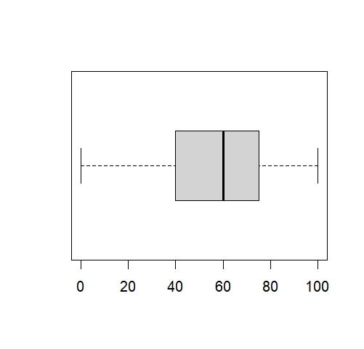
Time Saved

Min: 0
1st Quarter: 40
Median: 60
Mean: 57.83
3rd Quarter: 75
Max: 100
Mode: 50
IQR:
Midrange: 50
Range: 50
Variance: 536.86
Standard Deviation: 23.17

The statistics for time saved as a percentage when using AI are: the mean was 57.83, the mode was 50, the standard deviation was 23.17 with a variance of 536.86. For the five number summary, the minimum is 0, the 1st quartile is 40, the median is 60, the 3rd quartile is 75, with a maximum of 100. The minimum and maximum can be used to find the range which is 50 and the midrange is 50 too. The inter quartile range (IQR) is 30. Looking at the boxplot, the shape of the distribution is skewed to the left and there are no outliers.
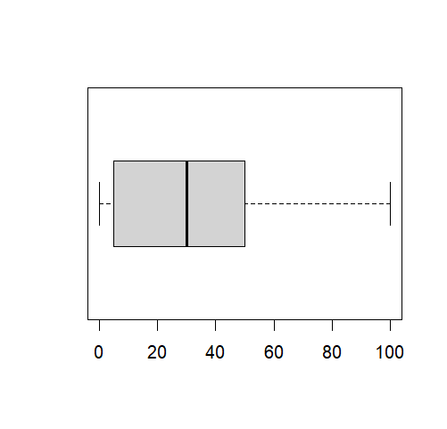

Grade Improvement

Min: 0
1st Quarter: 5
Median: 30.00
Mean: 32.49
3rd Quarter: 50
Max: 100
Mode: 0
IQR: 20
Midrange: 50
Range: 50
Variance: 804.09
Standard Deviation: 28.36

The statistics for grade improvement in percentages when using AI are: the mean is 32.49, the mode is 9, the standard deviation is 28.36 with a variance of 804.09. For the five number summary, the minimum is 0, the 1st quartile is 5, the median is 30, the 3rd quartile is 50, with a maximum of 100. The minimum and maximum can be used to find the range which is 50 and the midrange is 50 too. The inter quartile range (IQR) is 45. Looking at the boxplot, the shape of the distribution is skewed to the right and there are no outliers.

Body II: Hypotheses & Statistical Analysis
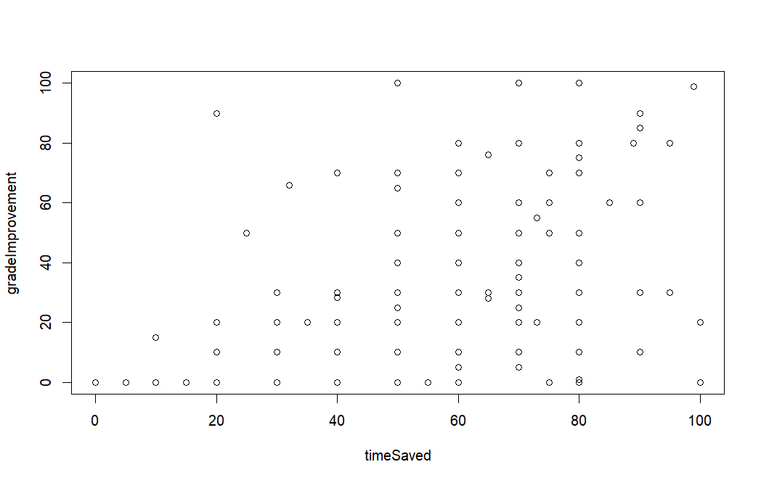
Linear or Nonlinear
As shown above, I generated a scatterplot within R software to compare time saved and grade improvement to see if there is a trend. The x-axis shows the time saved and the y-axis shows the grade improvement. From observing the scatterplot, the trend looks slightly positive and forms a moderate linear correlation. This could mean that grade improvement could correlate to time saved when utilizing AI. In order to find out if there is a true correlation, finding the correlation coefficient and hypothesis testing will need to be done.

Correlation Coefficient
To find the correlation coefficient, I entered the data into R software. The value of r² is 0.209 and the square root of r² is 0.4576, which is the correlation coefficient. Since there is a positive slope to the scatterplot and the x-axis is positive, 0.4576 is a positive correlation coefficient. This is one step further to prove that there is a positive correlation to time saved and grade improvement when utilizing AIs in studies.

r² = 0.209, r = $\sqrt{0.209 }$ = $±$0.4576

Hypothesis Testing
Before testing if time saved and grade improvement have a linear correlation, I will need to check if the data meets all three requirements. Since the data was gathered by giving out a voluntary survey to college students freshman to senior year, this is not a simple random sample, however, it is still quantitative due to time saved and grade improvement being percentage variables. The next requirement check is confirming the scatterplot has a linear trend. As stated above, the scatterplot is slightly positive and shows a moderate linear correlation. Lastly, there aren't any outstanding outliers therefore nothing needs to be removed from the data. Only two out of three of the requirements are met, this does not meet the requirements.

For my hypothesis I will be claiming that there is a positive correlation between time saved and grade improvement when it comes to utilizing AIs in your studies. H₀ represents the null hypothesis which states that there is no correlation between time saved and grace improvements when utilizing AI. The alternative hypothesis H₁ represents that there is a positive correlation between time saved and grade improvements when utilizing AIs in class. We will be using figure 0.05 as a value of significance a (alpha).

H₀: y = 0
H₁: y > 0

The test statistic is 6.039 and the p-value is 0. When comparing it with a, 0.05, it shows that the p-value 0 is less than a 0.05. This concludes that we can reject the null hypothesis and further prove there is a positive linear correlation to time saved and grade improvements when using AIs in class.
ŷ = 0.55952 + 0.13024x

Regression
We can also find the regression equation within R software by using the y-intercept 0.55952 and the slope 0.13024, which can be shown above. ŷ is the grade improvement and x is the time saved. An example would be if I wanted to save 30 percent of my time doing homework by using AI, my grades would approximately go up by 4 percent. It’s not a super positive correlation in grade but it does save time.

One last thing we need to test is if this regression equation is a good model or a bad model. This means that it needs to pass three conditions. The first one is scatterplot linearity, we have already confirmed that the data is linear. The second condition is to check if there is a linear correlation, we have already confirmed that there is a positive linear correlation. Lastly, is the data in the scope, meaning there is no extrapolation, yes it is in the scope. Therefore we can conclude that this is a good model.

Conclusion
After finding the linear correlation, testing the hypothesis, and finding the regression equation, we can conclude that you can definitely save time and improve your grades when you utilize an AI to help you study. However, there are other factors that could change the outcome of the results. For example, class attendance plays a big role when it comes to your overall understanding of the material. You also cannot just rely on AIs to do all your work for you to save time and improve your grades. It’s important to still understand the material yourself. All in all, there is sufficient evidence to support the claim that there is a positive correlation between time saved and grade improvement when it comes to using AIs in class.
R Software Codes

>AI=read.table(file.choose(),header=TRUE)
>AI

>timeSaved = AI$CI timesaved
>gradeImprovement = AI$CI gradeImprovement

>boxplot(timeSaved)
>boxplot(gradeImprovement)

>plot(timeSaved,gradeImprvement)

>summary(lm(gradeImprovement~timeSaved))
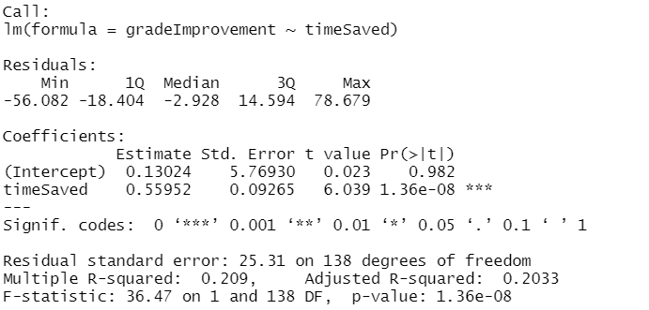
References

Abbad, Wlla (2023), “Education Process before and after using AI tools ”, Mendeley Data, V3, doi: 10.17632/c348gts9xx.3

Laskowski, N., & Tucci, L. (2024, April 15). What is Artificial Intelligence (AI)? everything you need to know. Enterprise AI. https://www.techtarget.com/searchenterpriseai/definition/AI-Artificial-Intelligence

R Core Team (2023). _R: A Language and Environment for Statistical
Computing_. R Foundation for Statistical Computing, Vienna, Austria.
<https://www.R-project.org/>.

